Parameter using SQL Statement
In this example, you connect to your database on SQL Server. In the SQL Server database window, after you enter your server details, select the Advanced options, then paste the SQL query into the SQL statement box, and then select OK.
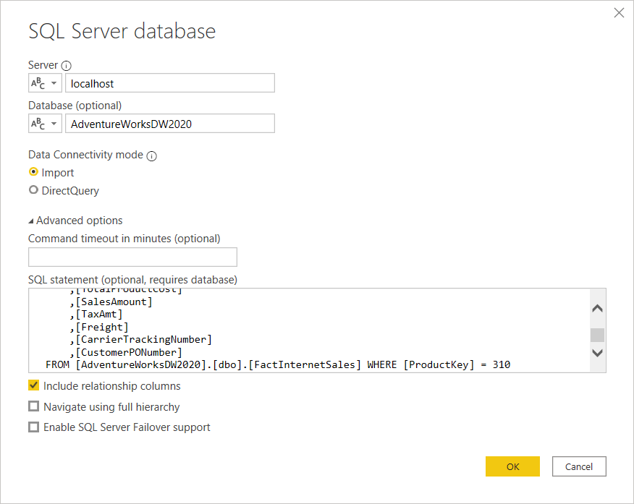
SELECT TOP (1000) [SalesOrderNumber]
,[SalesOrderLineNumber]
,[OrderDate]
,[DueDate]
,[ShipDate]
,[ProductKey]
,[CustomerKey]
,[PromotionKey]
,[CurrencyKey]
,[SalesTerritoryKey]
,[OrderQuantity]
,[UnitPrice]
,[ExtendedAmount]
,[UnitPriceDiscountPct]
,[DiscountAmount]
,[ProductStandardCost]
,[TotalProductCost]
,[SalesAmount]
,[TaxAmt]
,[Freight]
,[CarrierTrackingNumber]
,[CustomerPONumber]
FROM [AdventureWorksDW2020].[dbo].[FactInternetSales] WHERE [ProductKey] = 310

- Click connect and click Transform Data
- Create Parameter
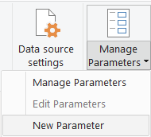
- Parameter name – ParamProductKey
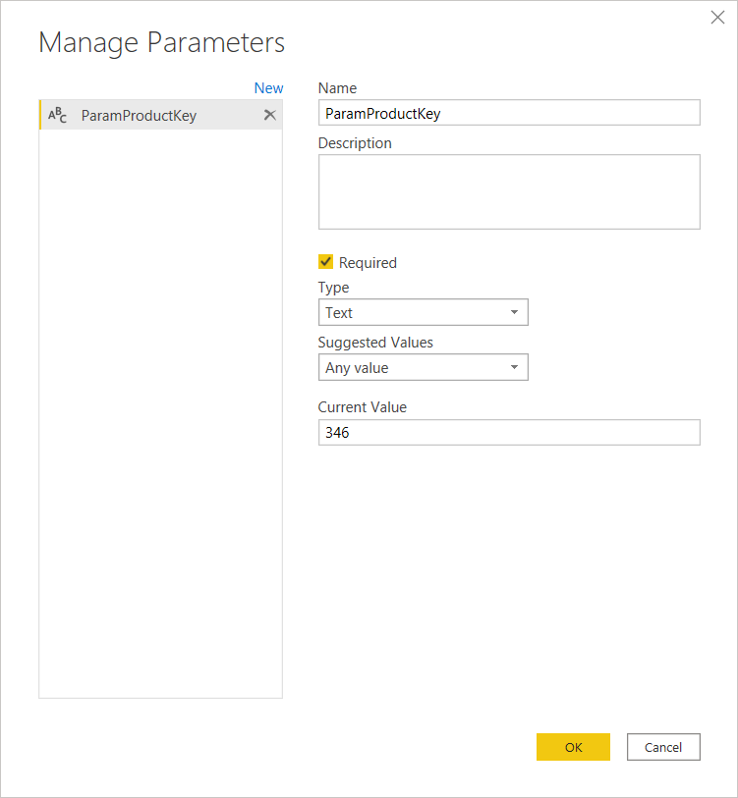

Update the Query with Parameter &ParamProductKey
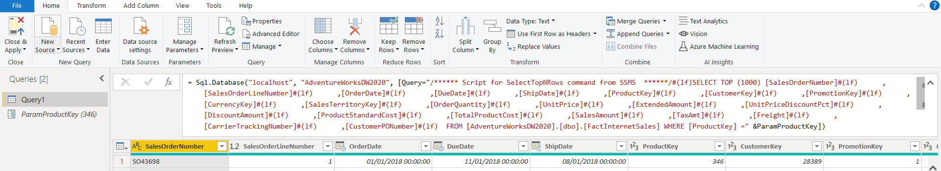
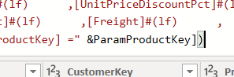

Close and Apply
Add visual
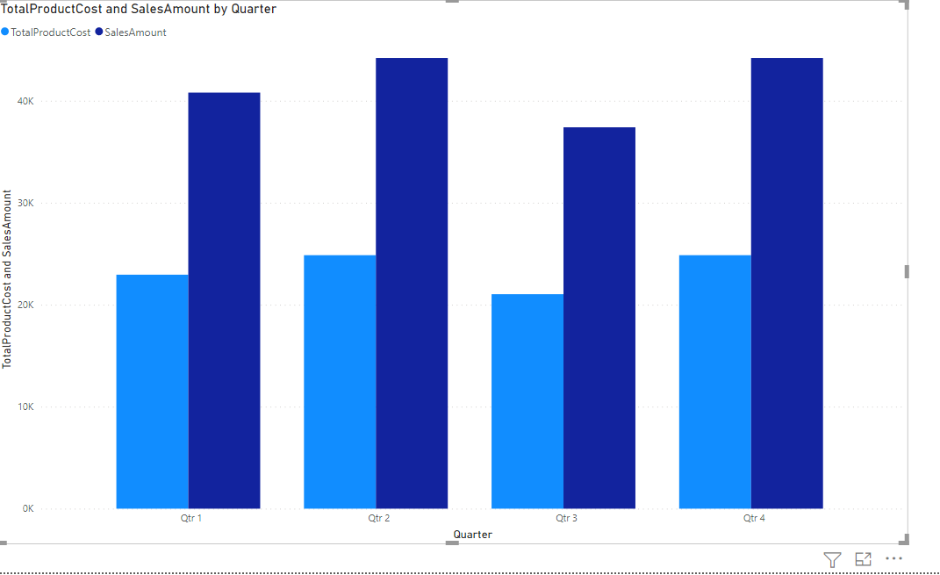
Then publish the report
Update the parameter based on the requirement via dataset parament
